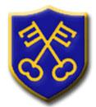 | ELWORTH C.E. PRIMARY SCHOOL  Headteacher: Mr N Garratt

E-PAYMENTS & MONIES INTO SCHOOL

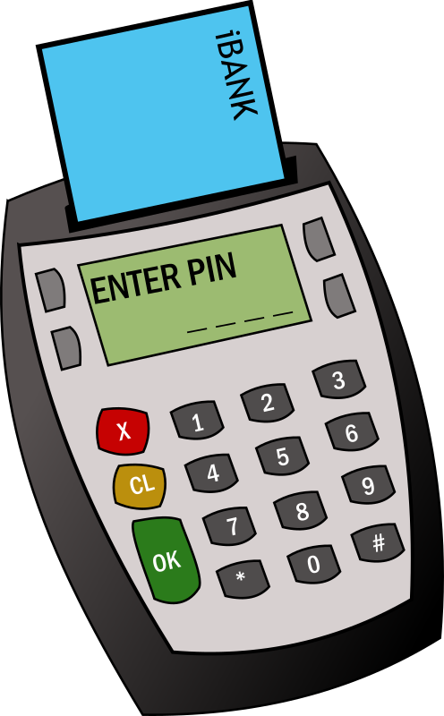
All consents and/or payments for trips, extra-curricular activity clubs and lunches are done through our MIS package, Arbor.
We ask that all parents set up their Arbor account as soon as we send links out.

LUNCHES & SNACK
As mentioned above our Lunch / Snack management system is Arbor. The children choose their snack and lunchtime meal at morning registration. The system will record what your child eats for snack and lunch each day, and will deduct the cost from your child's account. School meals cost £2.30 per day but are free for Reception, Year 1 and Year 2 under the Universal Infant Free School Meal scheme. Snacks vary in price from 25p to 60p and are chargeable to every child.

*please note that we ask that all meals accounts are kept in credit

EYFS children will not be offered a school snack for the first term and we ask that you provide a healthy snack for them each day.

PUPIL PREMIUM
If you are eligible for certain benefits your child could be eligible to receive in-school benefits including income-related free school meals (IRFSM), assistance with trips, additional tuition such as music and after school clubs and much more.

Just because your child receives a free school meal under the Universal Infant Free School Meal scheme (UFSM) doesn’t mean that they are eligible for Pupil Premium, However if they are eligible for Pupil Premium they could receive much more than a free meal. Please can we encourage you to look at the Pupil Premium forms that are part of the Transition information, and then if you think you may be eligible, you can apply online via the Cheshire East website. Select the Schools & Education option, followed by ‘Information for Parents’. From there you can select ‘Apply for FSM’ and then go into Income Related Free School Meals (IRFSM).

IF YOUR CHILD IS IN EYFS, YEAR 1 OR YEAR 2
IT IS WORTH CHECKING TO SEE IF THEY ARE ELIGIBLE.

WATER BOTTLES
We ask that all children bring a water bottle (containing just water, not juice ) into school please. The children are able to fill up their water bottles during the day if necessary

MEDICAL APPOINTMENTS
The school office need to be notified in advance of any upcoming medical appointments. This should be done by email to admincontact@elworthce.cheshire.sch.uk so that we can mark your child down as Medical on the register. The Admin team will then make sure that the class teacher is aware. We will also require a copy of the appointment letter or text. Failure to do so will result in an unauthorised mark.

48 HOUR POLICY
Just to let you know about our 48 hour policy. Any child with sickness and/or diarrhoea must be kept at home for 48 hours after the last episode. Thank you

UNIFORM & PERSONAL BELONGINGS
Please can we strongly urge all parents to name their children’s uniform and personal belongings

REPORTING ILLNESS
If your child is going to be absent from school due to illness you must contact school each day they are absent. You can call 01270 698914 and leave a message on the absence voicemail or email the school office. Please provide your child’s name, class and reason for absence.

